HANI ALSO INCLUDE GANNT CHARTS FROM PROJECT PROPOSAL AND PROGRESS REPORT!!!!

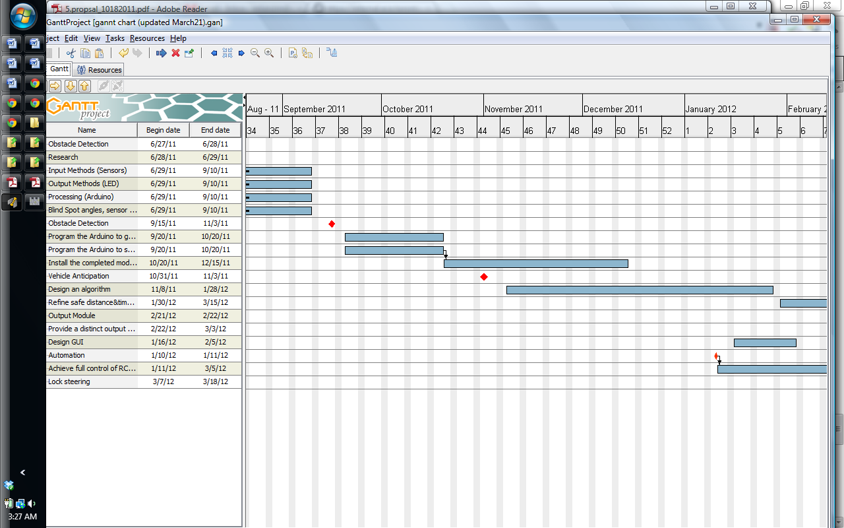

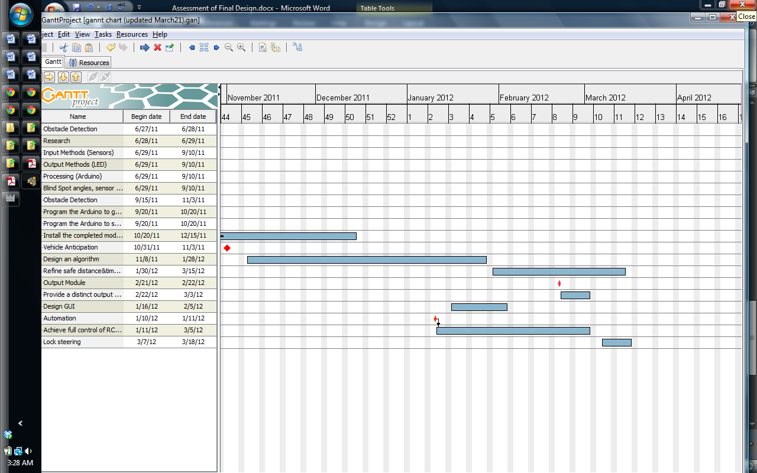

Updated in January

